1. **Open DSI Studio from the icon . Select “Step T3: Fiber tracking” and select the file containing the *fib.gz extension from the “Files” folder inside of the patient’s folder.**

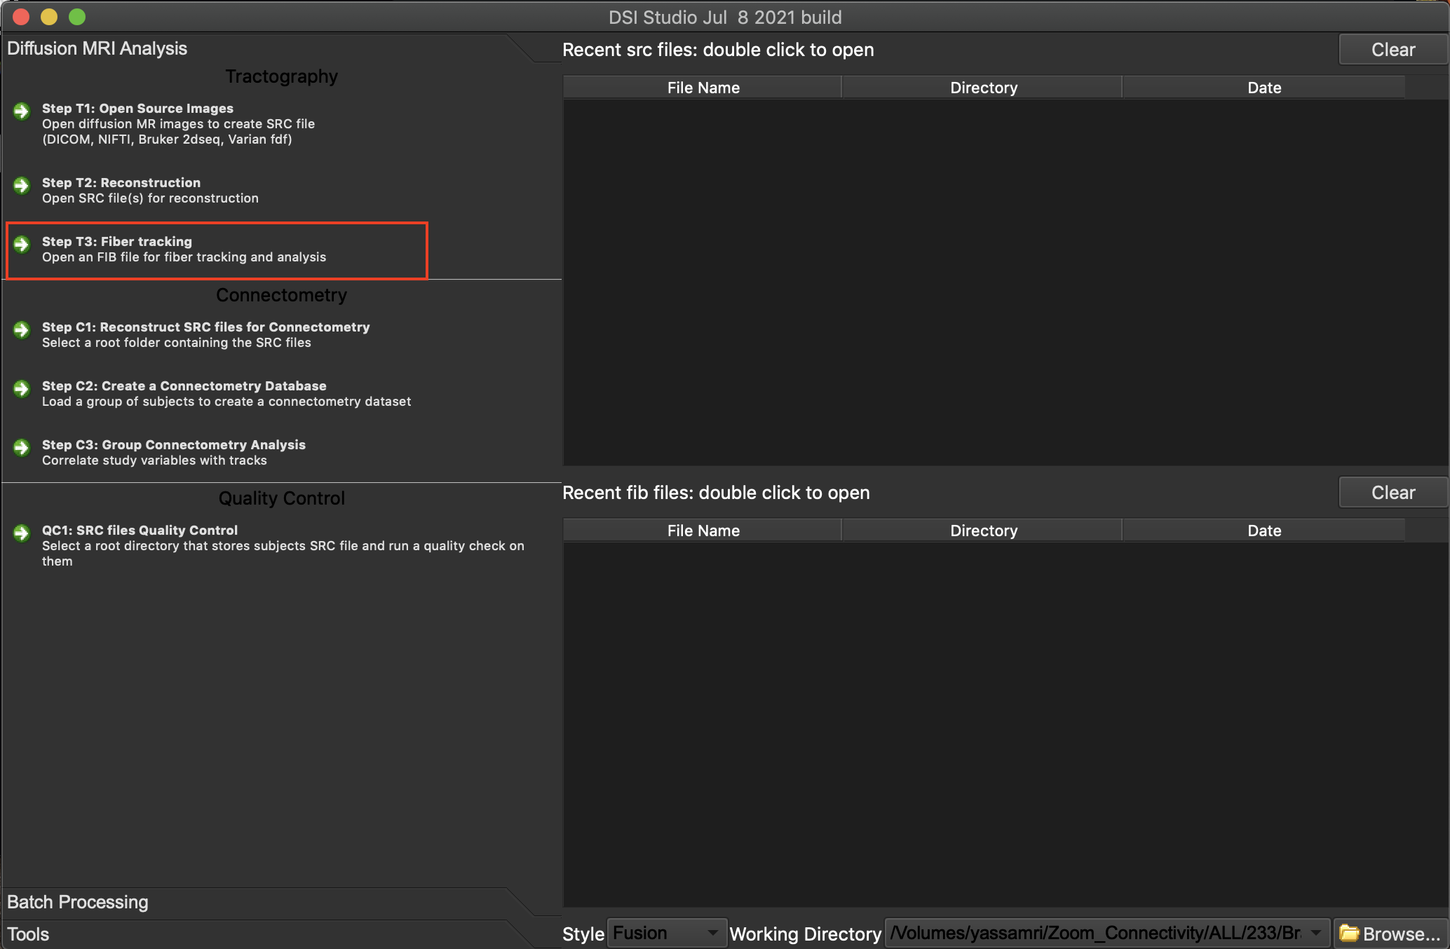

1. **You have now opened the Guided User Interface. To open tractography of the whole brain or specific tracts of interest select “Tracts” on the top panel and “Open Tracts…”.** 
   1. The whole brain tractography file is called count_connect.trk.gz and is located in the “Files” folder.
   2. Individual streamline files contain the extension *.tt.gz located in the “Files/tracts” folder. There is one file for each entry in the connectivity matrix.

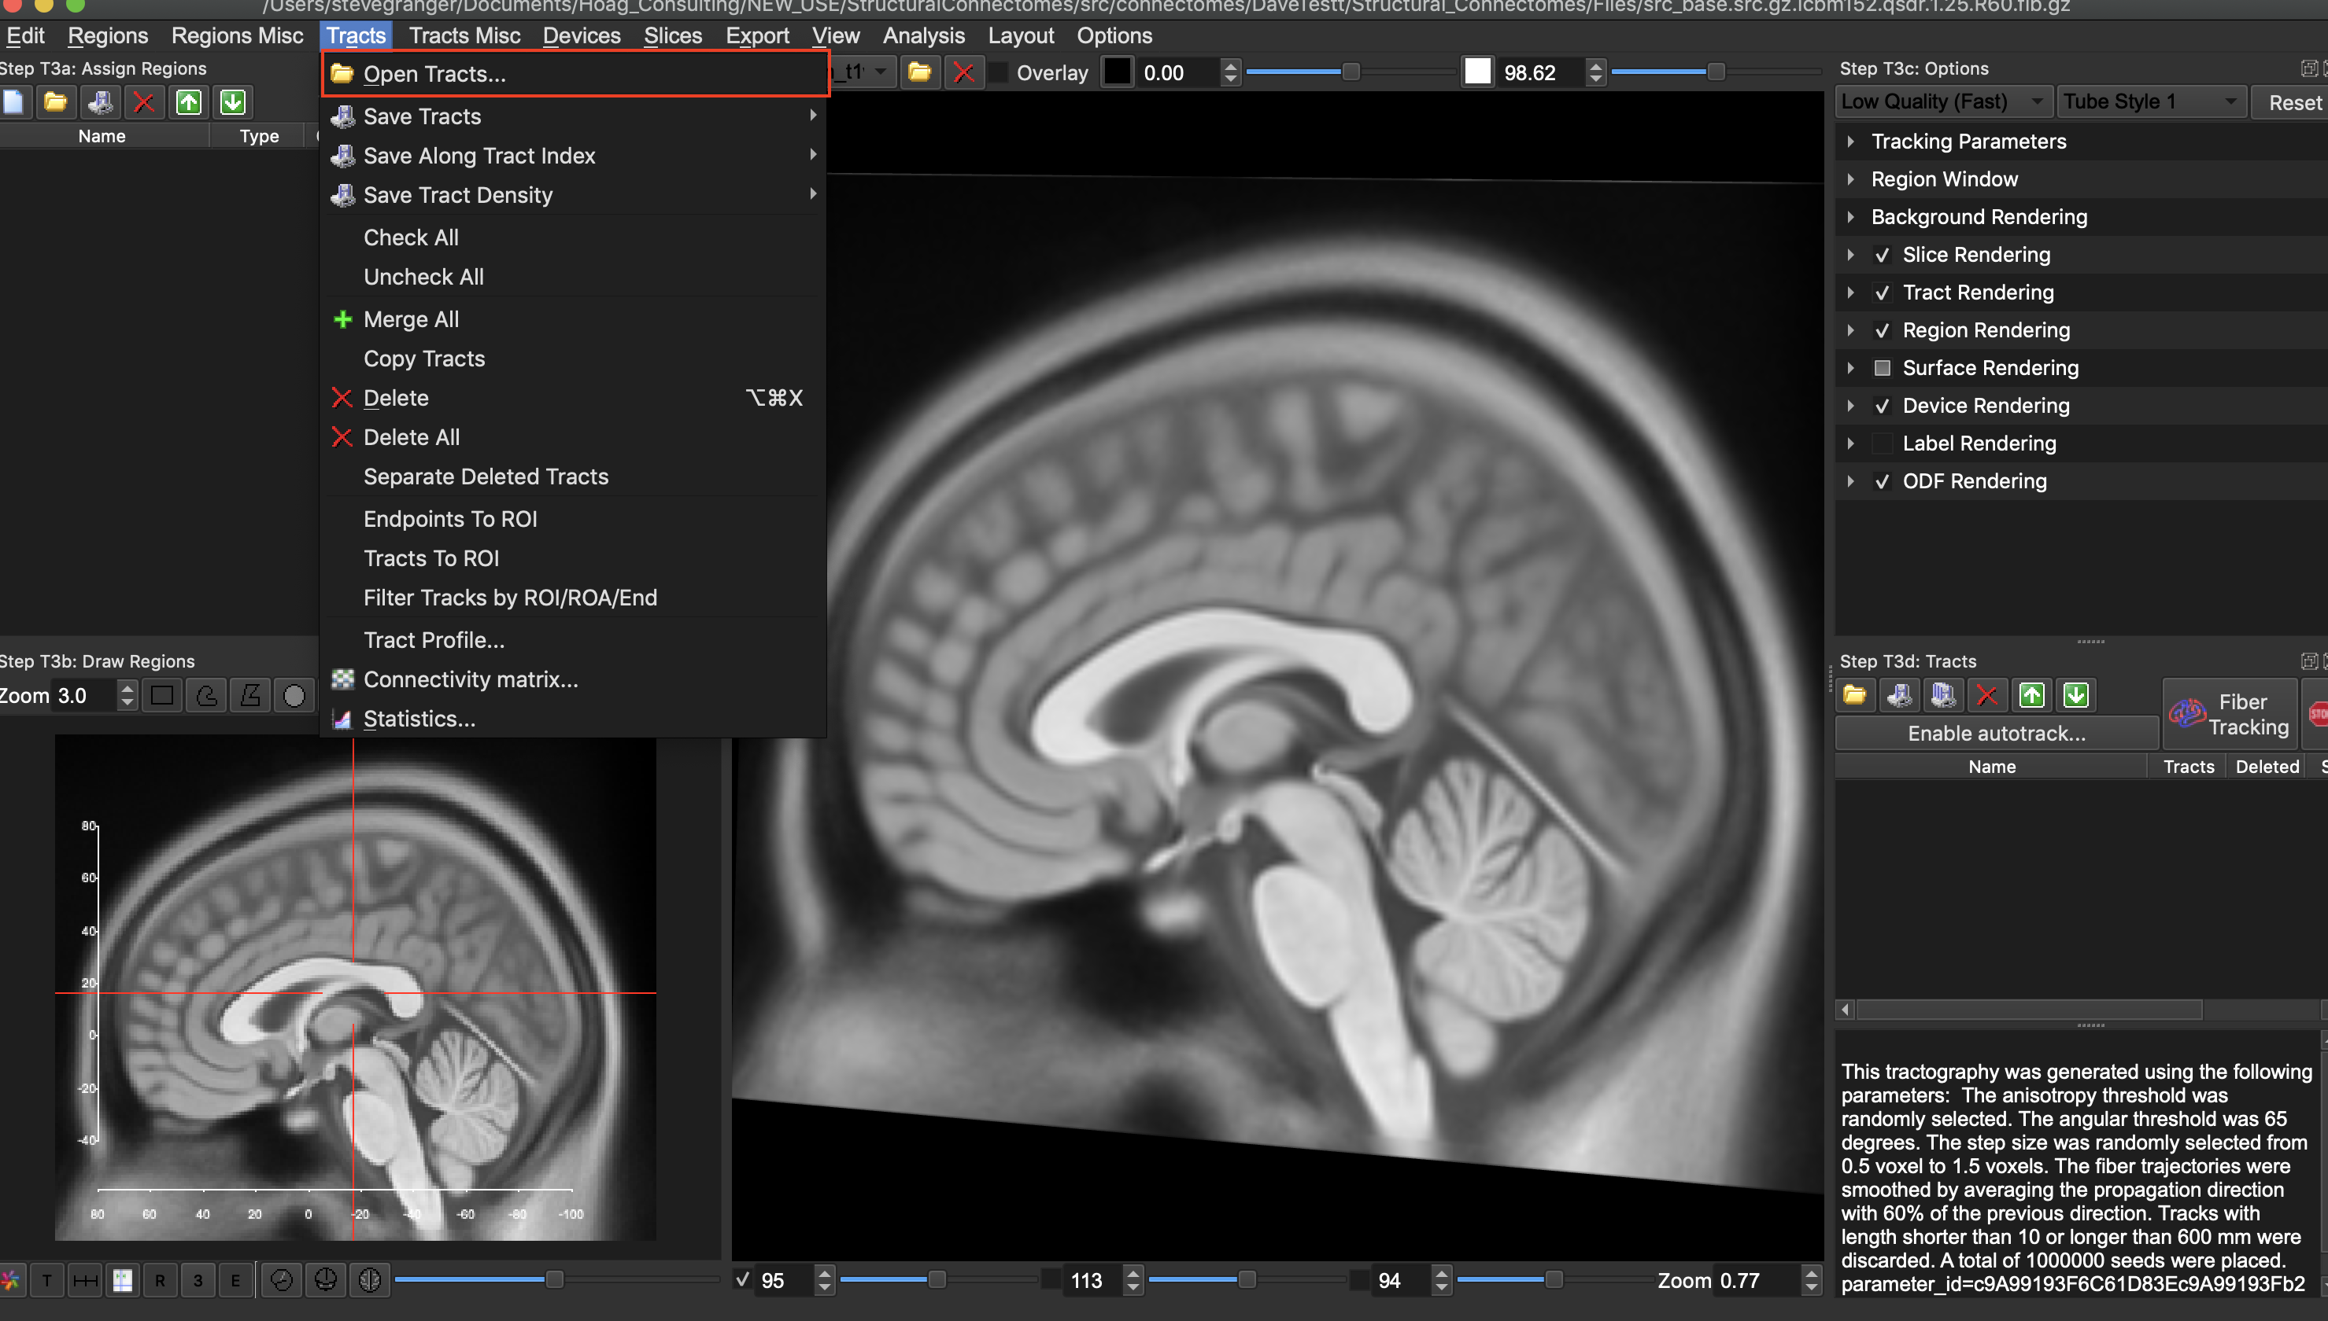

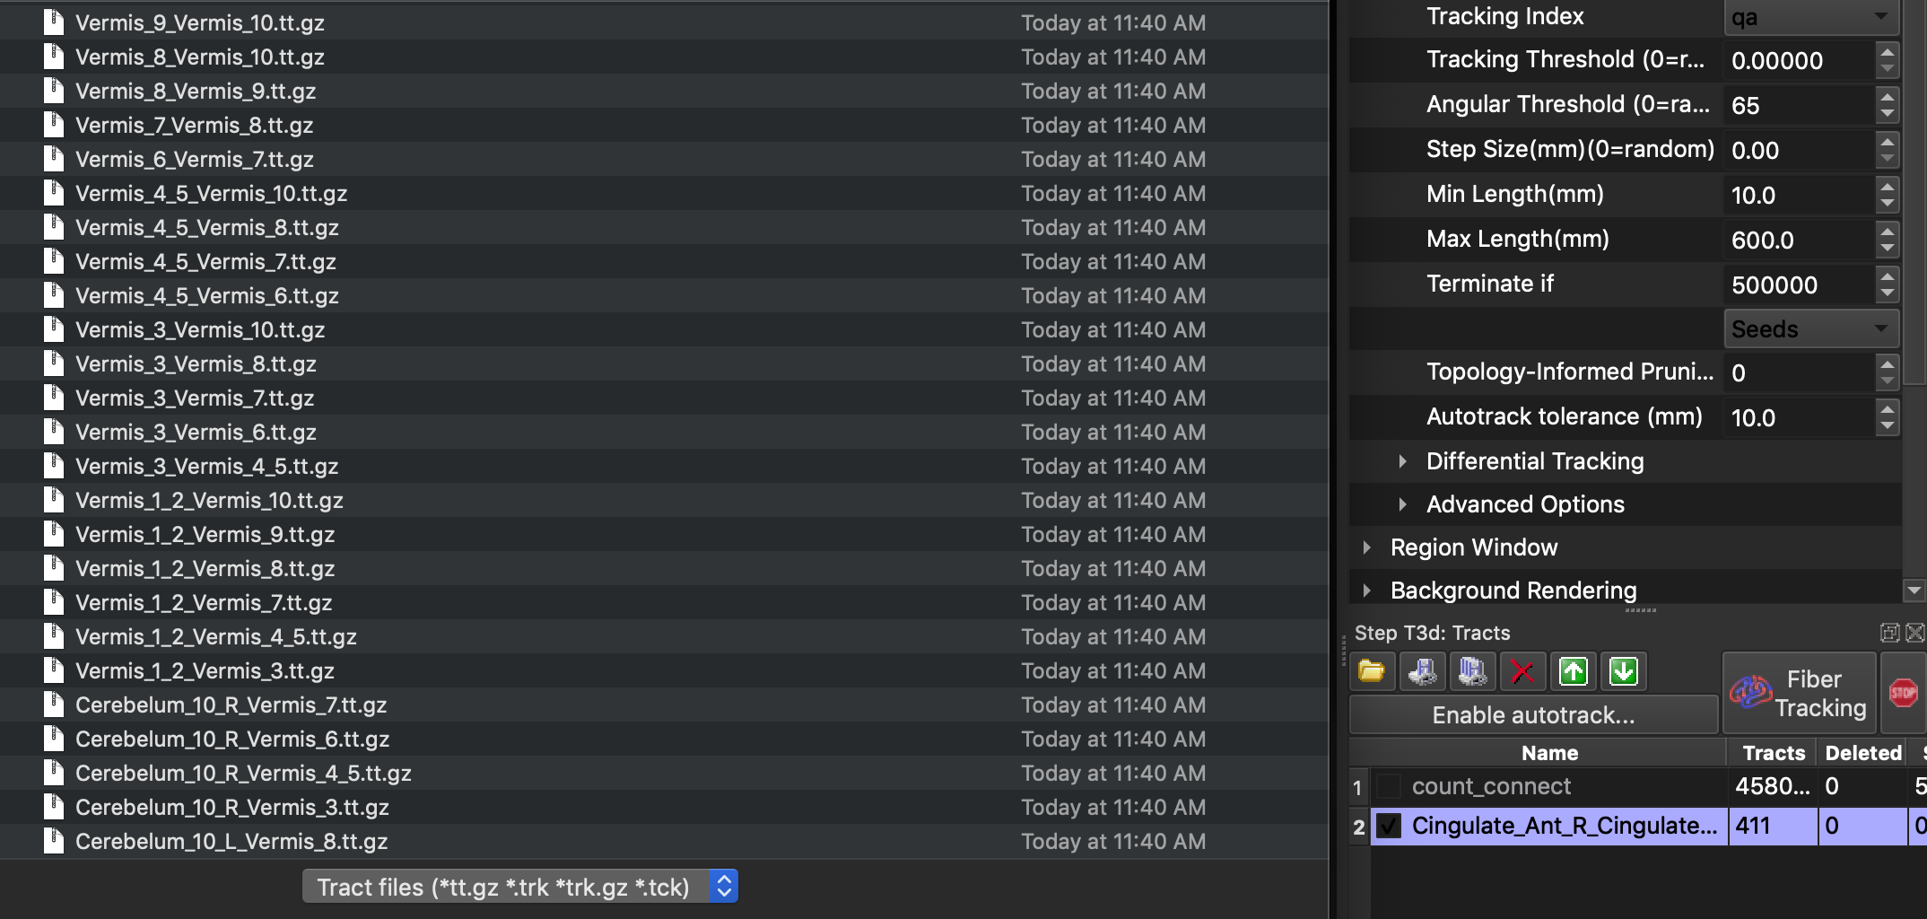

1. **The tracts or ‘streamlines’ will appear in the GUI. They can be selected or deselected by clicking the check mark next to the file name on the bottom right hand side of the window.**

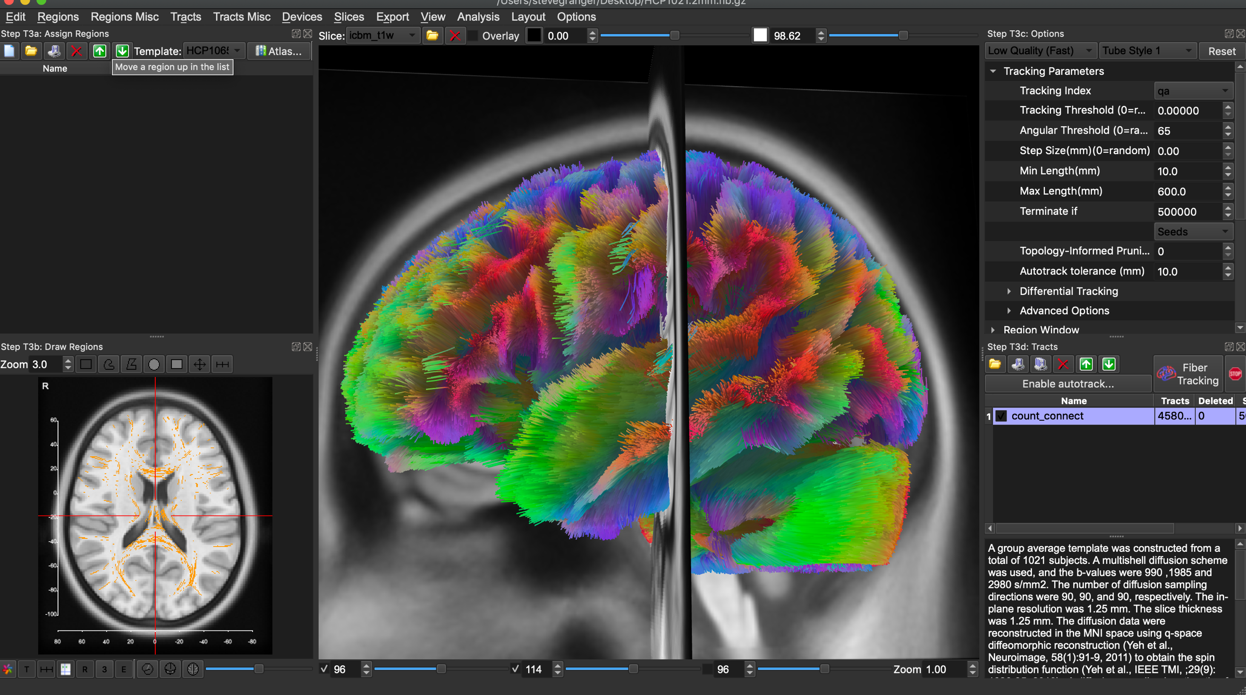

*(An example of whole brain connectivity calculated from a group average of 1021 Human Connectome Project subjects)*

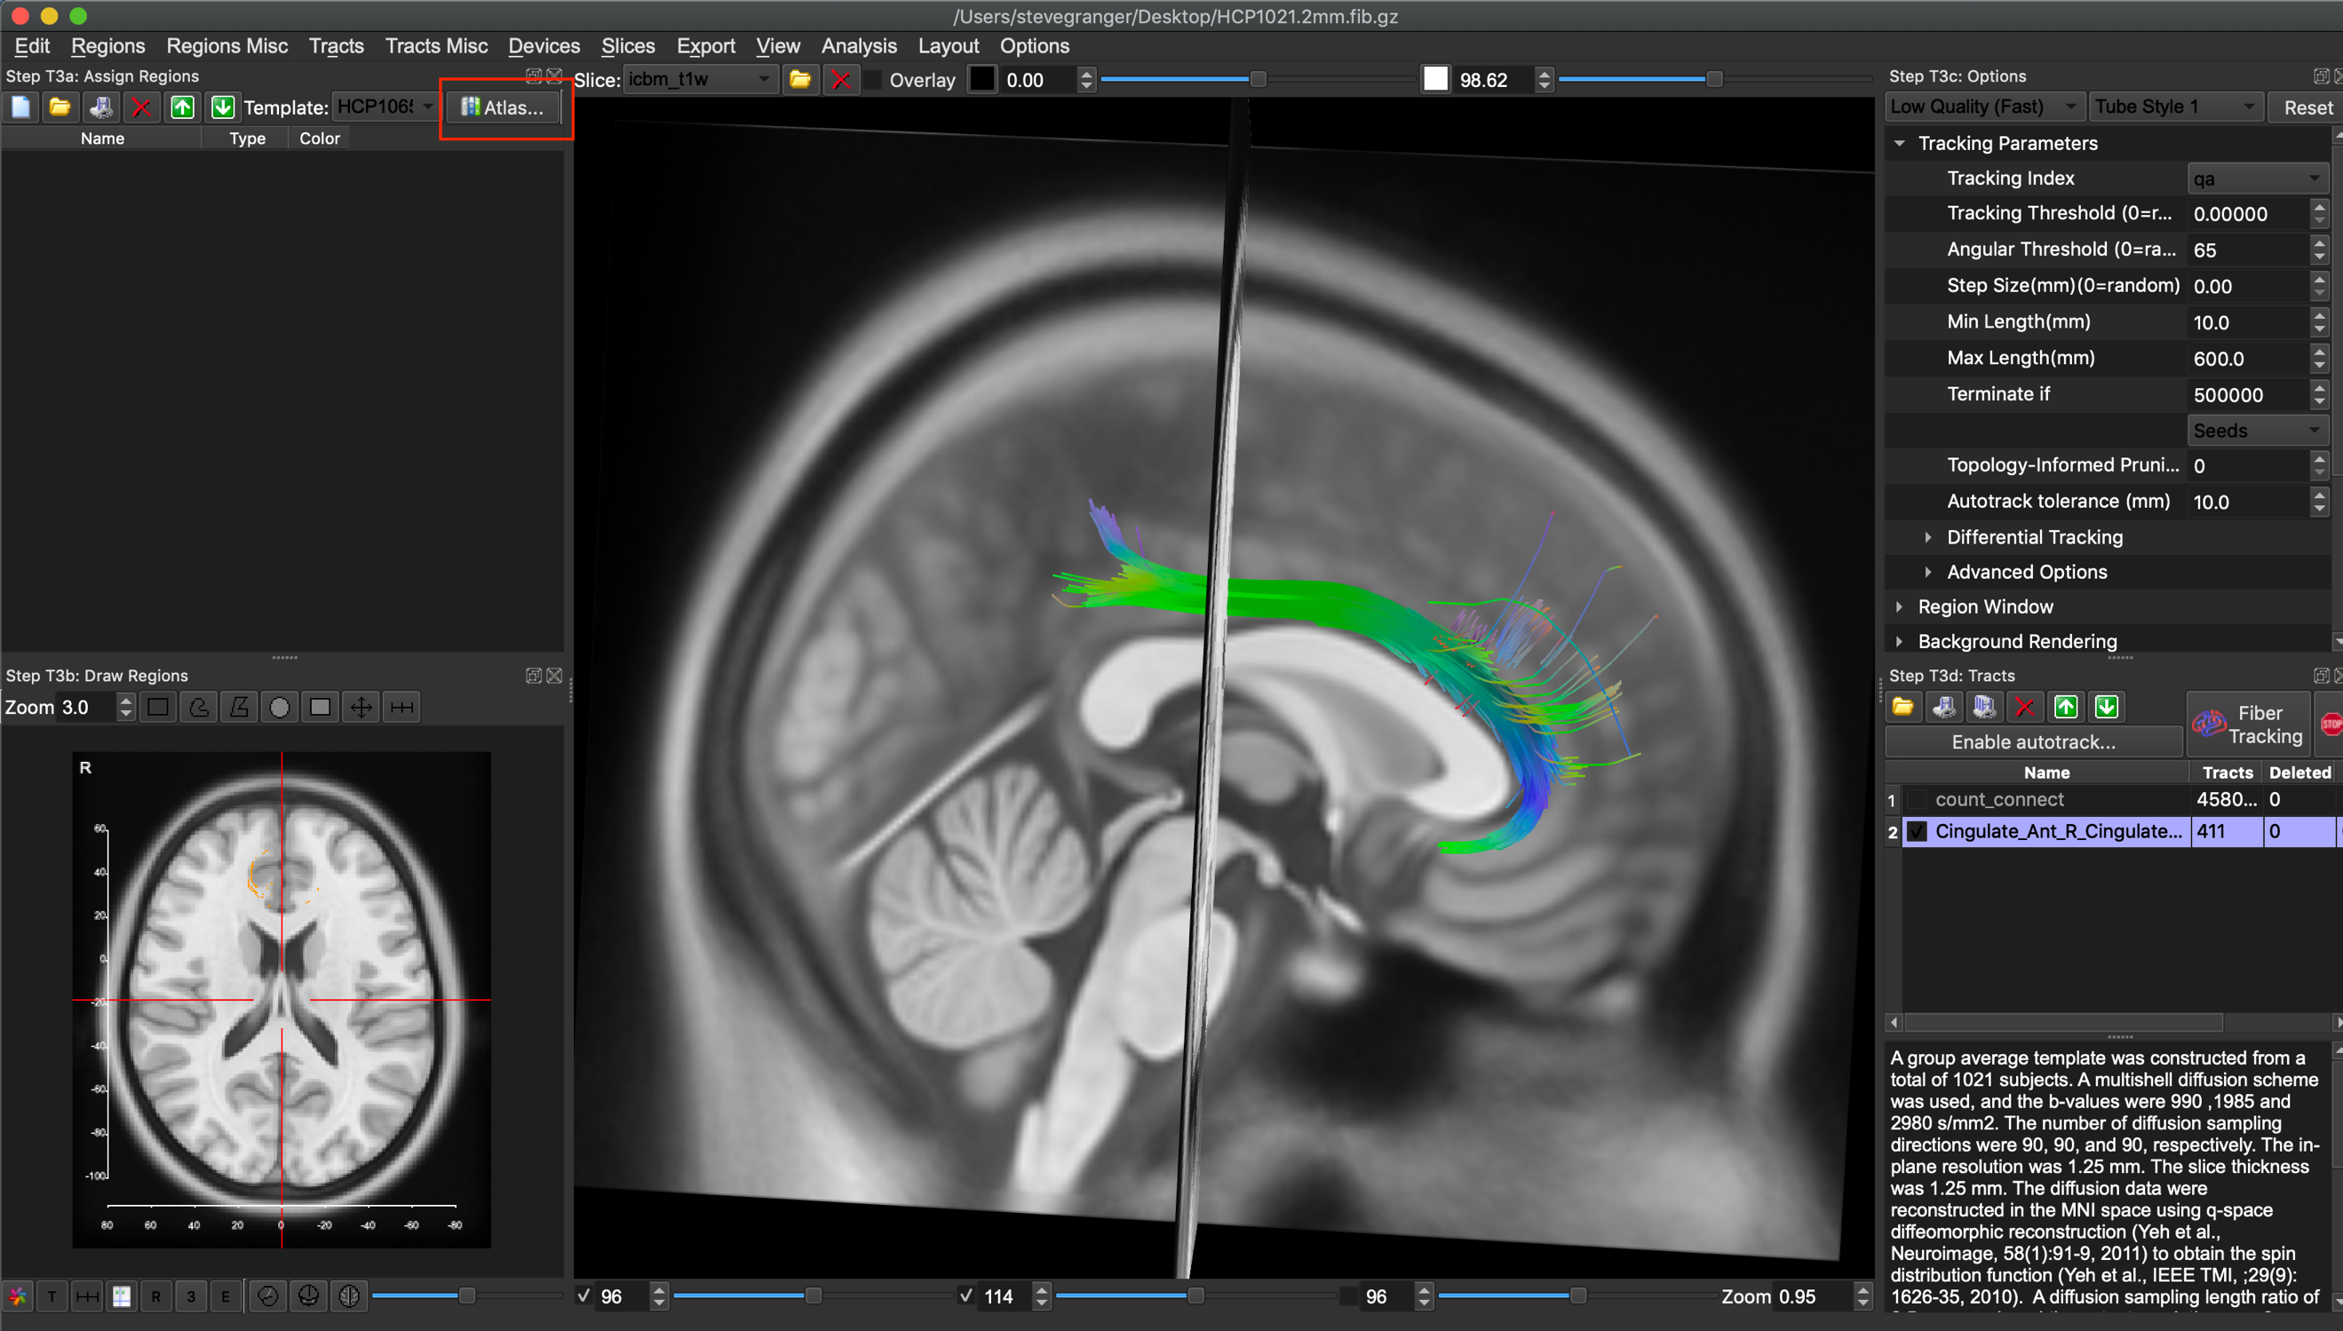

*(An example of node-to-node the “Cingulate_Ant_R_Cingulate_Mid_R.tt.gz” file)*

1. **To visualize the ‘end’ regions for the example streamline above. Select the “Atlas…” tab on the top left-hand side of the window. It is highlighted in the images above in red. Then, select the respective ‘end’ regions you would like to visualize. In this case select “Cingulate_Ant_R” and “Cingulate_Mid_R”**

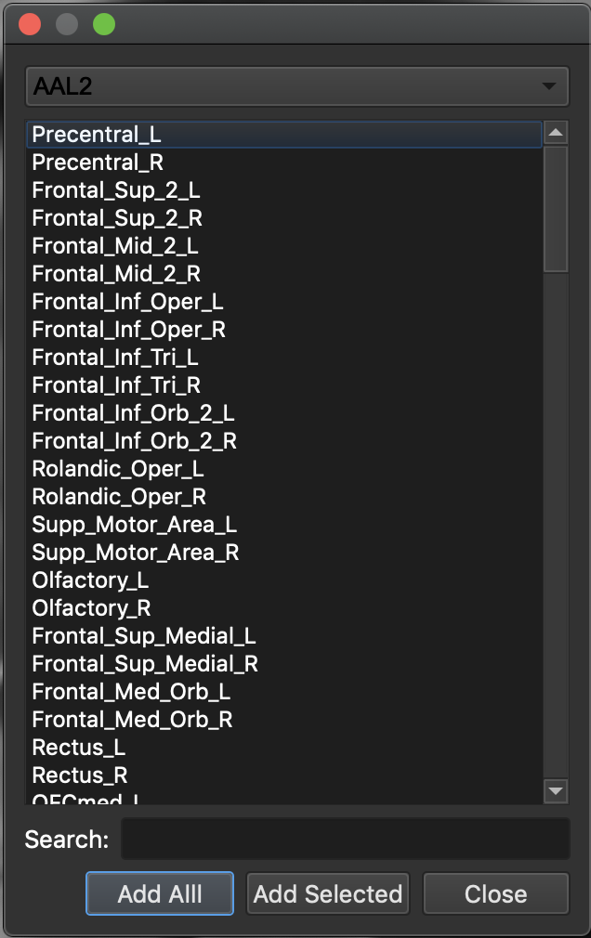

1. **The region files selected will appear in the left hand window. You can select and deselect them by either checking or unchecking the region name.**

